Outcomes from the GLANAM project – Fellow ESR11: Glacimarine sedimentary processes and products at fjord-terminating tidewater glacier margins

Tidewater glaciers are glaciers that terminate in the ocean, and often occur at the mouth of fjords that were carved by glacial activity. Many of these glaciers serve as fast-flowing outlets draining Earth’s remaining ice sheets into the surrounding oceans and therefore control ice sheet stability. Because these glaciers are not only influenced by air temperatures and internal glaciology but also by ocean temperatures, they are considered to be particularly susceptible to a changing climate and understanding their behaviour is crucial in terms of reconstructing ice sheet history, and by inference, predicting future ice dynamics. By studying the glacial geomorphology and sedimentary products from different High-Arctic fjords, the ESR11 project was able to reconstruct individual glacier dynamics and the main glacimarine sedimentary products in front of 17 different tidewater glaciers during deglaciation and throughout the Holocene. The main outcomes from this research are:
On a regional scale:
- First insights into the deglaciation history, the tidewater glacier dynamics, the submarine glacial landforms and the (rate of) sedimentary processes in a northeast Spitsbergen fjord.
- First insights into the detailed submarine glacial landforms and sedimentary processes in West Greenland, specifically in front of Jakobshavn Isbræ, the world’s fastest-flowing tidewater glacier. This, in turn, has new implications for our knowledge of retreat and stability of the Greenland Ice Sheet since the Last Glacial Maximum.
- Additional information and detailed insights into the landform assemblages and the (rate of) glacimarine sedimentary processes was obtained from new datasets collected from in front of tidewater glaciers in four Spitsbergen fjords.
- New insights into the landform assemblages and sedimentary products formed in front of surging glaciers, including the sedimentary processes and the rate of sediment accumulation during surges.
On a broader (Arctic) scale:
- Although the basic glacimarine sedimentary processes in front of High-Arctic tidewater glaciers tend to be relatively similar, their magnitude and the associated products are controlled by individual glacier configuration.
- The dynamics of tidewater glaciers can be quite different even within geographically restricted areas, which shows that they are not only governed by climate, but are rather subject to climatically-independent factors such as internal hydrology, internal thermal, pressure and stress regime, underlying bed topography, fjord bathymetry, and bedrock geology in the glaciers’ catchment areas. This seems to suggest that glacier dynamics cannot be generalised across wider geographic areas, which needs to be considered when predicting the glaciers’ future behaviour.
- This research provides a variety of new data which can be used in modelling past and future ice sheet behaviour, thereby making such models more accurate.
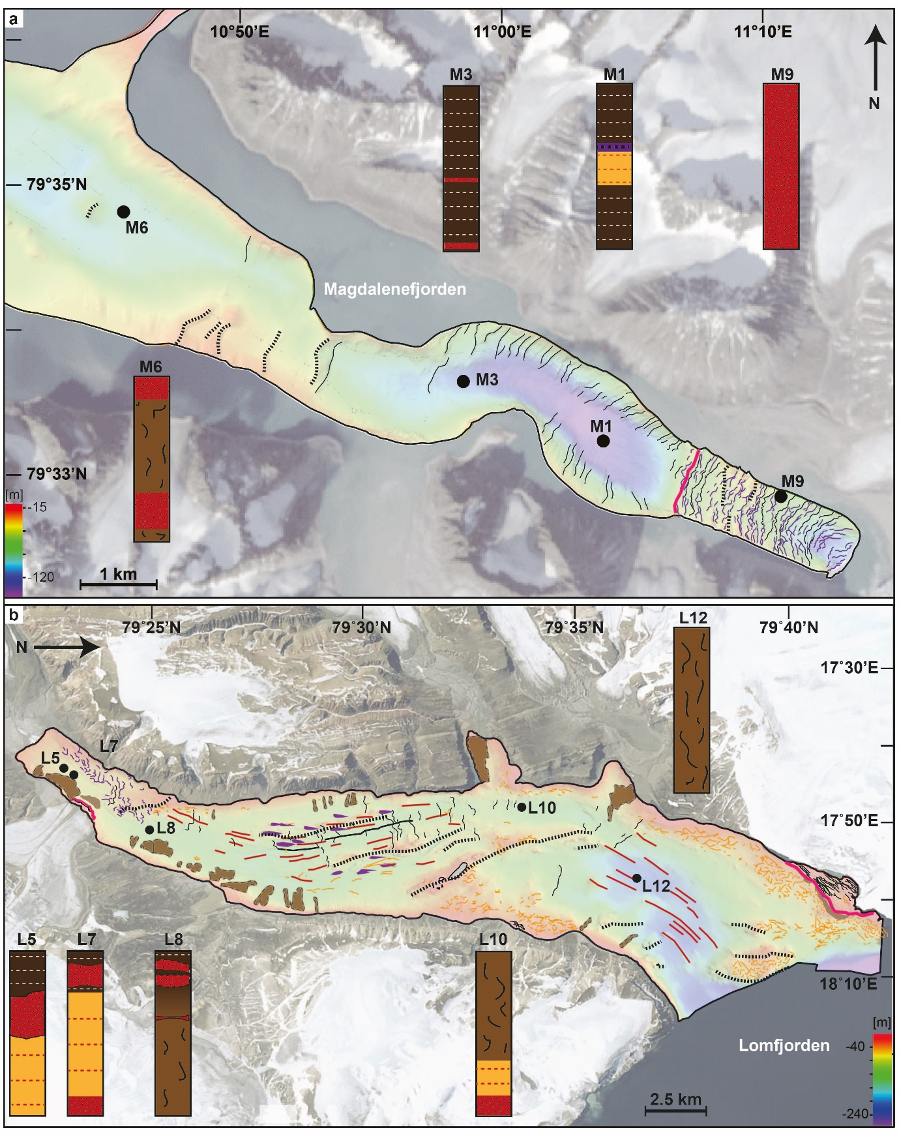

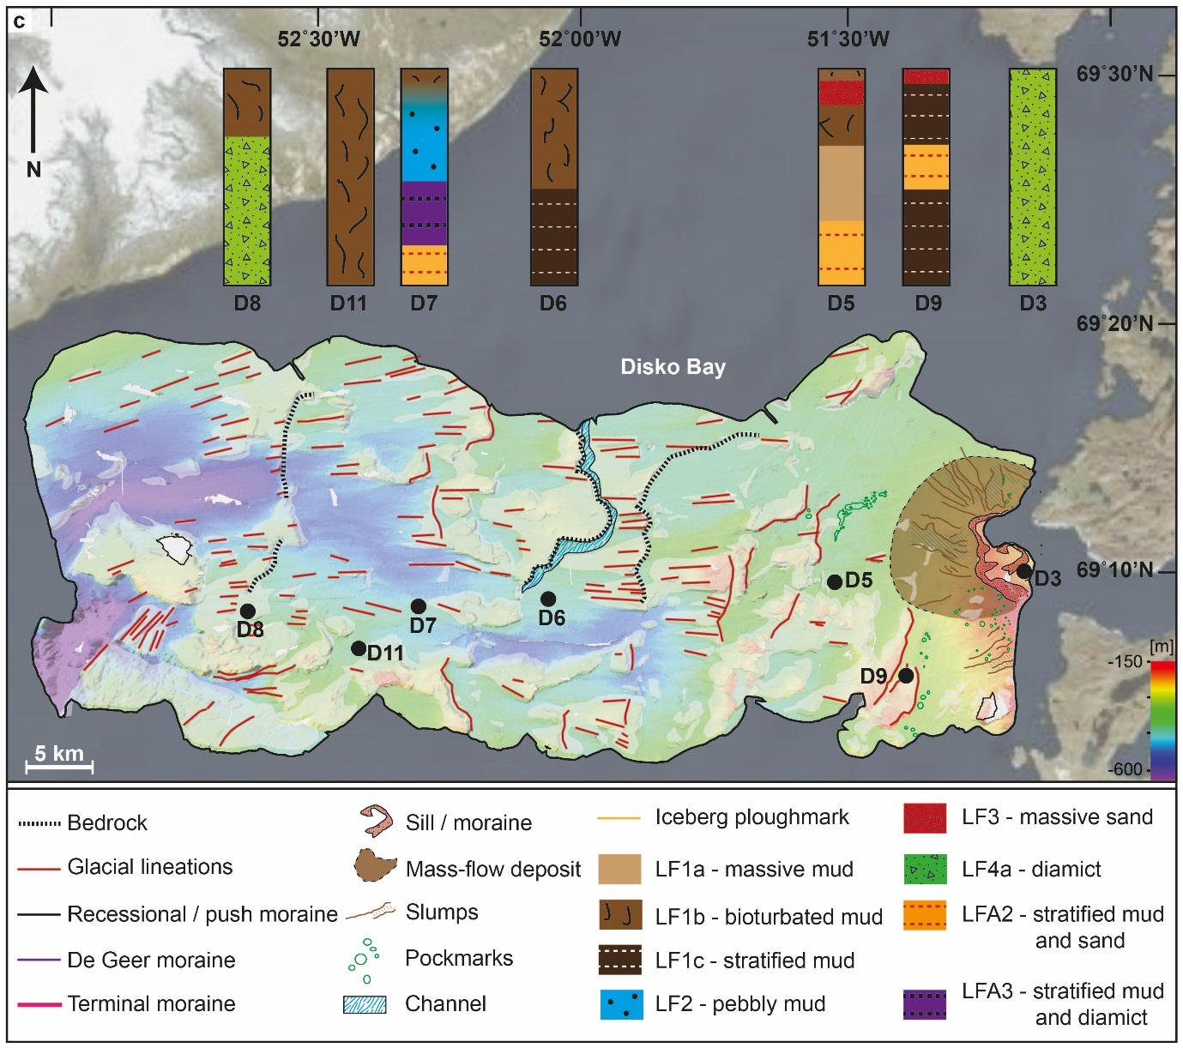
Figure 1: Examples of sediment-landform assemblages in three of the investigated High-Arctic fjords. A) Magdalenefjorden, northwest Spitsbergen. The glacier Waggonwaybreen formed the observed landforms and sedimentary deposits. B) Lomfjorden, northeast Spitsbergen. The landforms in most of the fjord were formed by an extended Veteranen glacier, which, during the Last Glacial Maximum served as a fast-flowing ice stream draining the Svalbard-Barents Sea Ice Sheet. More localised landforms at the coasts were formed by individual tributary glaciers throughout the Holocene. Sedimentary products reflect an interplay of a range of processes, controlled by at least four different tidewater glaciers and likely by a few terrestrial ones. C) Disko Bay, West Greenland. The landform-sediment assemblage was formed during and after the Last Glacial Maximum beneath and in front of an advancing, then retreating Jakobshavn Isbræ.

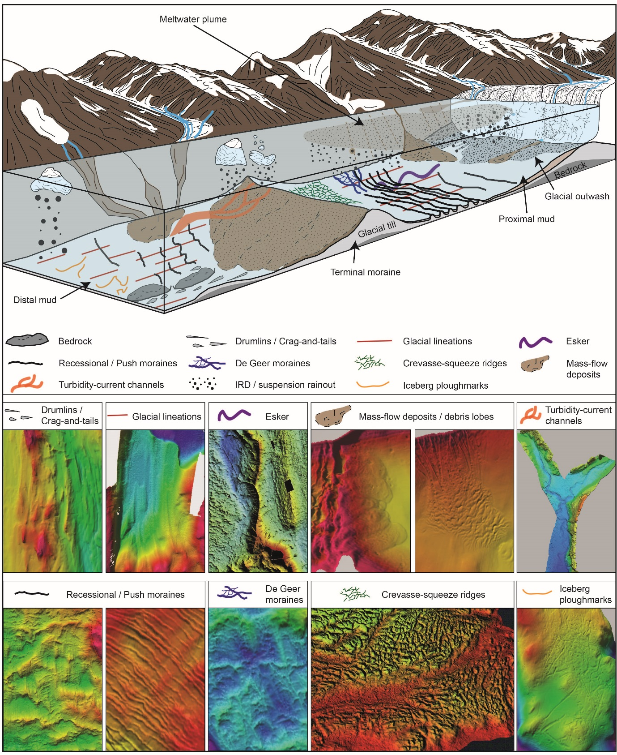
Figure 2: Conceptual model of the sedimentary processes and associated products in front of contemporary tidewater glacier margins. The model is based on the data available for the ESR11 project but also includes observations from Alaska, East Greenland and the Canadian Arctic described in the literature.

