Dimitrios Ktenas, ESR 12
On the Norwegian Continental Shelf (NCS), the western Barents Sea margin is generally ice- free and more accessible than any other arctic region, and is also a frontier area for hydrocarbon exploration. During the Mesozoic and Cenozoic, most of the areas of the Barents Sea were subjected to several episodes of uplift and erosion.
The key challenges in oil and gas exploration in the Barents Sea are related to the effect of this erosion and uplift. More precisely, these effects are related to the shut – off of hydrocarbon generation due to cooling of the source rocks, top seal and / or fault seal failure combined with a long retention time of hydrocarbons and change of hydrocarbon properties. Timing is therefore crucial for guiding future exploration activities in the study area.
The goal of this project is to combine geological projects based on seismic interpretation, shale compaction calculated from sonic logs, vitrinite reflectance data combined with rock physics models and porosity loss trends in order to estimate the amount of net erosion and the timing of the uplift. The industrial partner North E&P AS provided both supervision as well as the key data sets (well and seismic data) for the research.
The main findings of this study are summarized below:
- The study identified areas with missing sections and major erosion at several places along the regional seismic interpreted profiles in the southwestern Norwegian Barents Sea. (Figure 1)
- Normal Compaction Trend (NCT) models from the published literature were investigated in order to have a better understanding of the velocity constraints of a new NCT model from available well-log data. Based on velocity trends and interpretation of seismic data, a new NCT model including the Triassic section was applied at great depths and to areas that have been deeply eroded. The new NCT model is calibrated to the Upper Cretaceous shales in the Haltenbanken area, Mid-Norway and the North Sea. The trend was then extended deeper into the Lower Jurassic-Triassic units of the Barents Sea subsurface. This new NCT model gives a good estimation of net apparent erosion for each of the selected wells, consistent with geological observations.
- A new net erosion map was constructed for the SW Barents Sea based on 40 wells. The highest erosion estimates are observed towards Svalbard, with highs up to 2600 m. Previous uplift maps for the western Barents Sea indicating a general trend of uplift and net erosion increasing towards east and north. (Figure 2)
- The results from different areas will also help us to understand the rock physical behaviour of different lithologies and will be a useful input for the on-going studies in velocity inversion and modelling of the petroleum systems in the eroded areas. The findings will further serve as input to the overall understanding of primary hydrocarbon migration models, secondary migration following fill-spill and finally to a qualified estimate of seal potential of identified traps in the Barents sea.
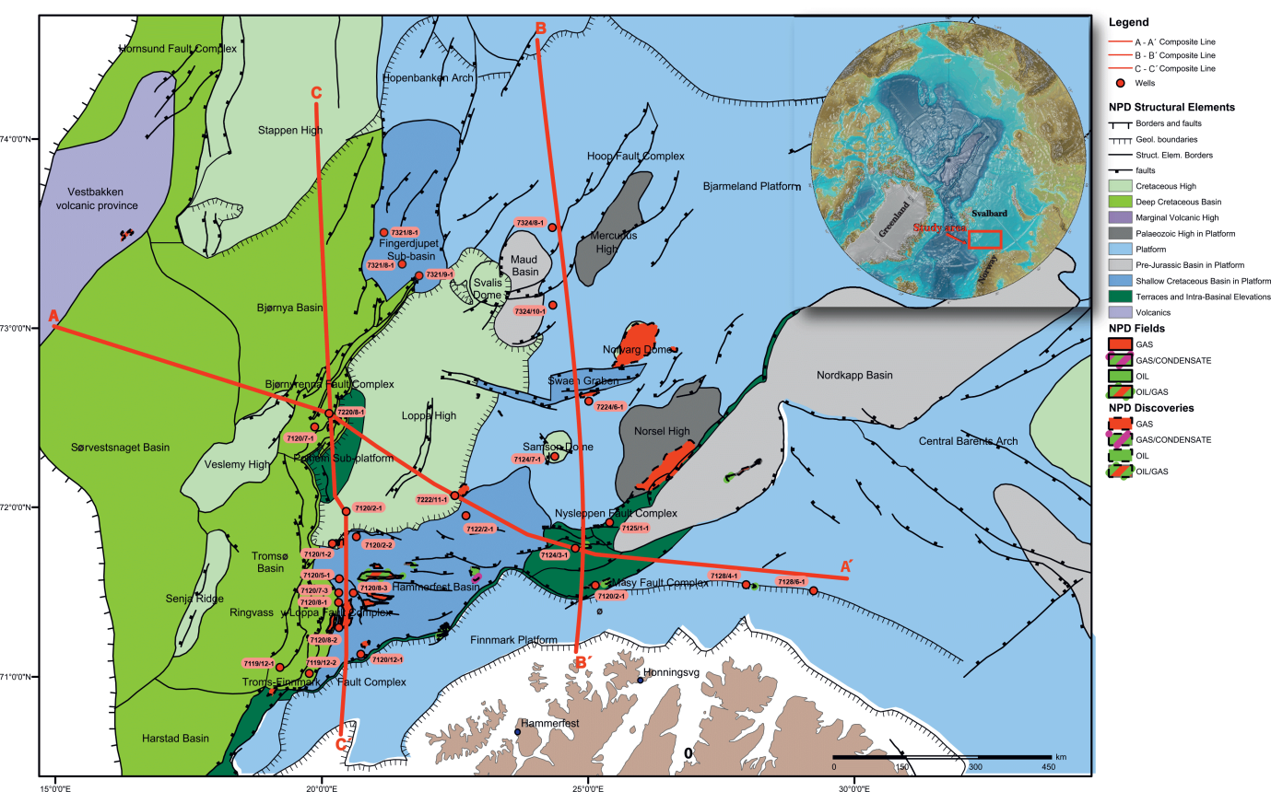
Figure 1. Map of the Norwegian Barents Sea showing the different structural elements and oil-gas discoveries. The available regional seismic profiles A-A’, B-B’, C-C’ and the provided wells along the lines are indicated with a red colour and red dots, respectively. The location of the study area is indicated in the inserted figure (Modified from the Norwegian Petroleum Directorate, NPD, Jakobsson et al., 2008 and Ktenas et al., in preparation)
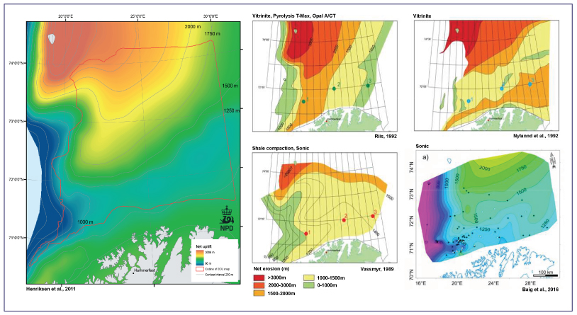
Figure 2. Previous uplift and net erosion maps for the Norwegian Barents Sea indicating a general trend of uplift and net erosion increasing towards the east and north. In some areas there are rather large differences in the estimates. (Modified from Ktenas et al., in preparation)

