The stability of contemporary ice sheets is largely influenced by the discharge from ice streams and calving of ice margin, while on a smaller scale their dynamics is regulated by the ice-bed interactions. Reconstructions of palaeo-ice stream dynamics based on geomorphological mapping contributes to understanding of ice stream sensitivity to the ocean-climate system and can aid in the numerical modelling of future changes in contemporary ice sheets. In this study, imprints of Barents Sea Palaeo-Ice Sheet (BSIS) - considered an analogue to contemporary West Antarctic Ice Sheet - have been used to reconstruct dynamics and determine factors influencing the configuration of its SW and S part. Based on 3D seismic dataset from the central Bjørnøyrenna (Bear Island Trough), 10 ice-streaming events, operating from maximum glaciation to ~15 ka BP, have been identified, indicating much higher temporal and spatial flow variability of the ice sheet than previously suggested (Fig.1). The data also revealed a previously unobserved topographically independent streaming event sourced directly from the E of the Barents Sea Ice Sheet. Some of the linear geomorphological features (MSGLs) identified as a product of ice streaming during deglaciation of BSIS, suggest a massive calving events as indicated by unprecedented evidence of continuous transition between MSGLs and iceberg ploughmarks. Base Quaternary surface reconstructed from 3D seismic data from Nordkappbanken, on the other hand, reveal glacitectonic features - hill-hole pairs - related to fast flowing ice. Identified hill-hole pairs were inferred to have been formed in Cretaceous, poorly consolidated bedrock through subglacial thrusting and erosion of material and its deposition downstream. Mechanism of their formation was linked to a fast flowing ice stream (as indicated by MSGLs) and may have resulted from a change in properties of underlying bedrock (to easily erodible Cretaceous rocks) and potentially the presence of a fault zone, or shallow hydrocarbon accumulations, which could act as sticky spots for the moving ice, impeding its flow (Fig.2).

Highlights:
- Ten streaming events of the Barents Sea Palaeo-Ice Sheet identified in Bjørnøyrenna, SW Barents Sea imply complex spatial and temporal flow variations and switch in flow directions from one ice streaming event to another (varying from W to SSW oriented).
- Ice flow in Bjørnøyrenna was of two types: pure, non-topographically constrained during maximum-style glaciation, like the LGM (Fig. 1, Stage 1) and ephemeral and locally variable ice streaming events during deglaciation (Fig. 1, Stages 2-10)
- Factors influencing the dynamics and configuration of the SW and S part of the Barents Sea Palaeo-Ice Sheet include externally triggered changes in geometry of the Barents Sea Ice Sheet (associated with migration of ice divides and likely the saddle collapse), and by variations in topography/bathymetry and associated calving of the ice stream front.
- Glacitectonic hill-hole pairs in Nordkappbanken area (related to maximum glaciation of the Barents Sea) are likely a result of shallow hydrocarbon accumulations impeding the flow and changes in underlying geology from Palaeogene harder rocks to easily erodible Cretaceous rocks.

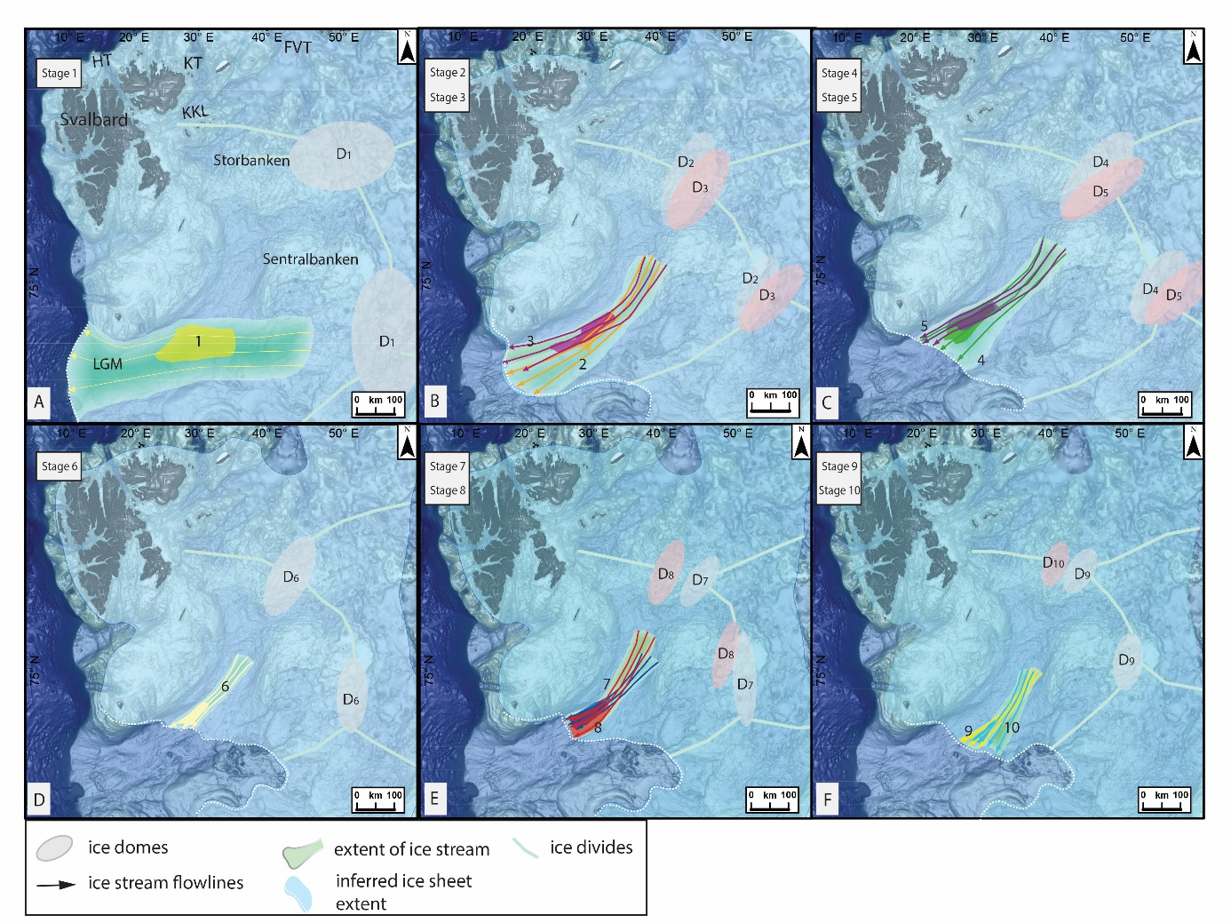
Figure 1. Deglaciation of Bjørnøyrenna. Stepwise reconstruction of the SW Barents Sea Ice Sheet deglaciation from maximum-style glaciation like the Last Glacial Maximum (~21 ka BP) to mid-deglaciation (~15 ka BP), showing frequent changes in trajectory and extent of identified flowsets and associated ice divides migration. The extent of ice streaming was inferred based on the interpreted ice stream flowlines and the extent of MSGL assemblages. The BSIS extent is from Hughes et al. (2015), with ice margins in Bjørnøyrenna adjusted to the extent of flow-sets identified in this study; background bathymetry from IBCAO (Jakobsson et al., 2012). Abbreviations: HT–HinlopenTrough, KT–Kvitøya Trough, FVT–Franz Victoria Trough.

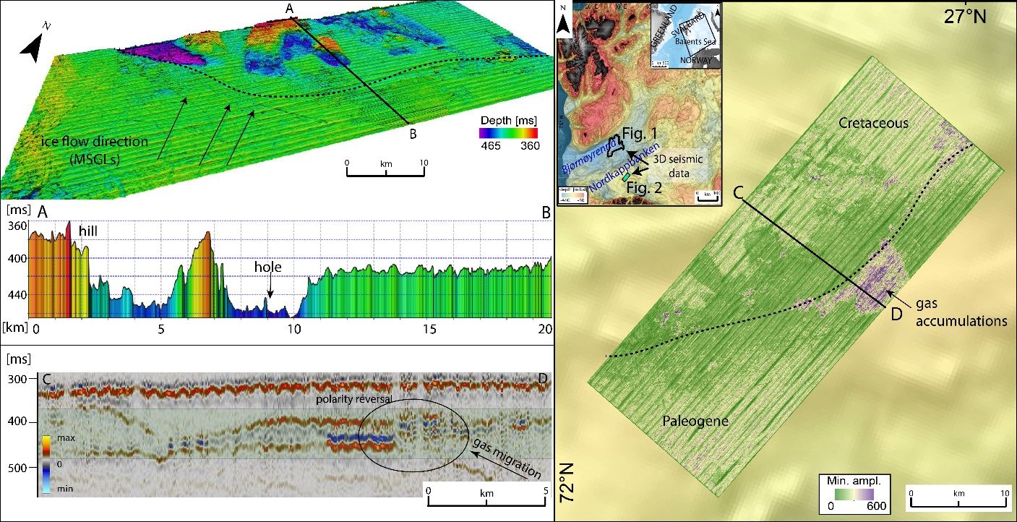

Figure 2. Glacitectonic features – Nordkappbanken, SW Barents Sea. A perspective view of the relief base Quaternary surface showing several SE-NW oriented linear groove features interpreted as MSGLs–an indicator of fast ice flow towards the glacitectonically deformed area. Section A-B displays a topographic profile across the hill-hole pair. Minimum amplitude map (right) showing an amplitude anomalies within the boundary zone (fault complex) between Paleogene and Cretaceous bedrock and partly in the glacially deformed areas. Seismic cross-section through the amplitude anomaly exhibits features characteristic for hydrocarbon occurrence–polarity reversal, strong amplitude reflection and acoustic masking (shaded area).

