Riccardo Arosio - Ice Streaming from western Scotland and deglaciation of the Hebrides Shelf and Firth of Lorn (ESR 5)

The rationale
Modern glaciated environments are undergoing change: ice shelves are collapsing, ice stream are changing flow speed and direction, ice margins are retreating and glacier surfaces are lowering. These changes are most significant for marine-based ice sheets and have been critically observed by scientists only for the last 70 years, therefore a full understanding of what they will entail on long-term ice sheet stability and behaviour is not known. The study of paleoglaciated environments in the Northern Hemisphere can provide the much-needed information on how ice sheet systems evolve over hundreds to thousands of years. Moreover, key processes that occur in the subglacial or ice-contact environment can be investigated. In this context of paleo ice-sheet reconstructions, this project examines geological records from the marine-based sector of last British-Irish Ice Sheet (BIIS) on the western Scottish shelf. The main aim is to interpret the results in the wider context of Scottish ice-sheet dynamics after the LGM.

The methods
- Geomorphology and stratigraphy - mapping and identification of glacial bedforms using the bathymetric data on ArcGIS and facies analysis of seismic profiles to assess the stratigraphy of the study area.
- Geochemistry - identify the source and fluctuation of ice streams delivering sediment to the study area through Pb, Sr and Nd isotope ratios in sediment detrital fraction. Measurement of radiogenic Pb isotope ratios from the leached fraction to constrain the intensity of chemical weathering fluxes from the continental crust on very high-resolution timescales.
- Sedimentology - analysis of sediment cores to describe the evolution of the sedimentary environment in response to ice configuration and retreat. The different methods are X-ray photography, multi-sensor-core-logging, grain-size analyses and foraminifera assemblages.

Some research conclusions
- At least two different flow directions of ice-streaming are observed in the Firth of Lorn ad Sound of Jura area, indicating a change in ice-sheet flow dynamics during the final demise of the same.
- A consistent pattern of de Geer moraines was identified in the Sound of Jura unlike the Firth of Lorn, where the retreat was arguably faster. The different behavior is ascribed to incongruent bedrock geomorphology.
- Sedimentological studies and ¹⁴C ages from long piston cores from the Muck Deep (South of Isle of Skye) show the persistence of glaciomarine conditions up to at least 10 k radiocarbon years.
- The Pb, Sr and Nd isotopic signature of the detrital fraction indicates a preponderance of Moine-sourced fine sediments (originated from the NW Highlands) on the western shelf, probably dictated by the orientation of ice flow, tidal current directions and sediment delivery from ~18 to 14 ka BP

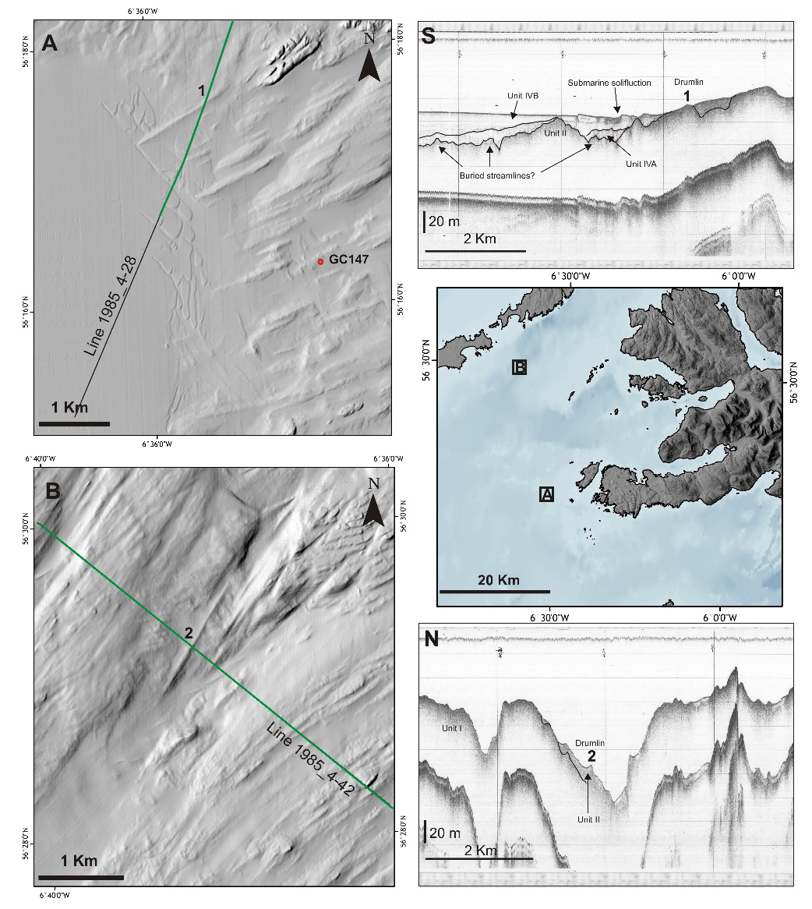

Figure 1 – Correlation between seismic evidence from BGS Pinger data, MBES data in the Iona area and SAMS GC 147.
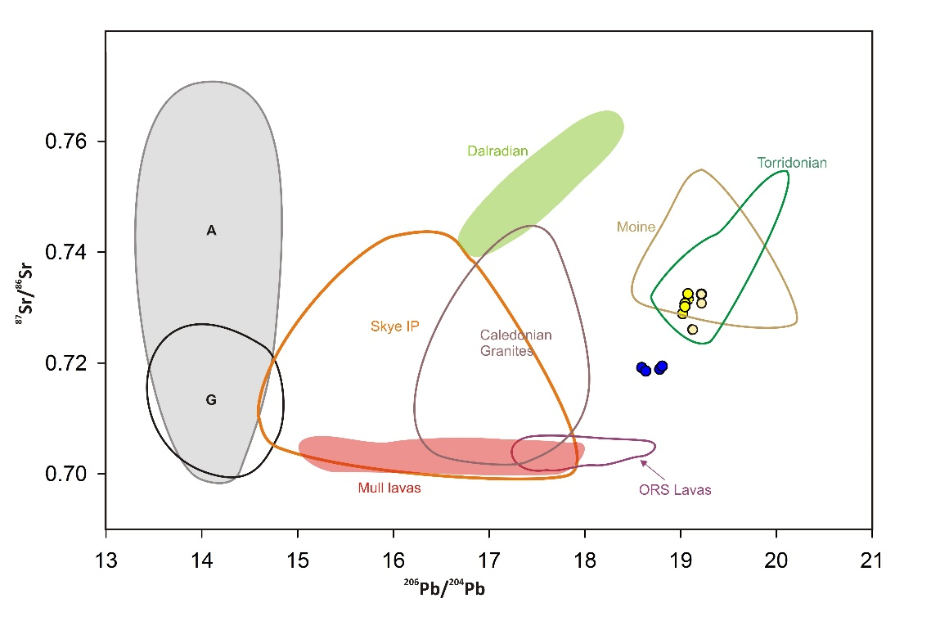
Figure 2 - ⁸⁷Sr/⁸⁶Sr vs ²⁰⁶Pb/²⁰⁴Pb plot of samples from core 149 (small circles, located ~15 miles SW Tiree) against western Scottish sources.

