Elena Grimoldi – ESR 7 GLANAM

Pleistocene Ice Sheet history of the western North Sea
Within the GLANAM network, my project is focussed on the western North Sea and particularly on the marine sector off the eastern coasts of England, delimited by Dunbar to the north and Hartlepool to the south (Fig. 1a). The main aim of my research consists in the collection and analyses of new geophysical and sedimentological datasets in order to reconstruct the last phases of the British and Irish Ice Sheet (BIIS) before deglaciation, with particular emphasis on the flow pathway and way of retreat of the North Sea Lobe (NSL) ice stream. In fact, despite significant improvements in our understanding of the last phases of BIIS recession in the onshore record of northern England, substantial gaps exist in our knowledge of the offshore deglaciation patterns. This research aims to rectify these knowledge gaps in the offshore record of BIIS dynamics using new evidence from the western North Sea.
The analyses of new high resolution multibeam bathymetry, 2D seismic profiles and five vibro-cores, collected in the western North Sea in collaboration with the Britice-Chrono project during the JC123 oceanographic survey (Fig. 1b and c), provide new insights on the seafloor geomorphologies and acoustic and lithological facies that characterize the Quaternary sediments of the area.

Main findings:
- Reconstruction of the offshore imprint of the NSL from the identification of numerous geomorphologies on the seafloor:
Bedrock-cored lineations orientated WNW-ESE to NW-SE indicate that the NSL was fed by the Forth ice stream, which moved offshore from southern Scotland.
Moraine ridges and two grounding zone wedges (Fig. 2), perpendicular to the lineations, suggest that the NSL underwent different phases of stillstand/readvance and indicate a slow retreat. The direction of ice retreat was towards the north-west.
- Five acoustic facies (AF) were identified in the study area (Fig. 2), four of which are found on top of pre-Quaternary strata (AF 1), though their lateral extension is discontinuous. They are interpreted to represent glacigenic diamicts (AF 2 and 3), that are overlain by glacimarine (AF 4) and by Holocene deposits (AF 5).
- Two radiocarbon dates collected within the glacimarine lithofacies suggest that the NSL was retreating from the central part of Area 2 (Fig. 1) around 19,454±193 cal. yrs. BP and by 16,816±229 cal. yrs. BP had retreated back into beyond the central part of Area 1 (Fig. 1).
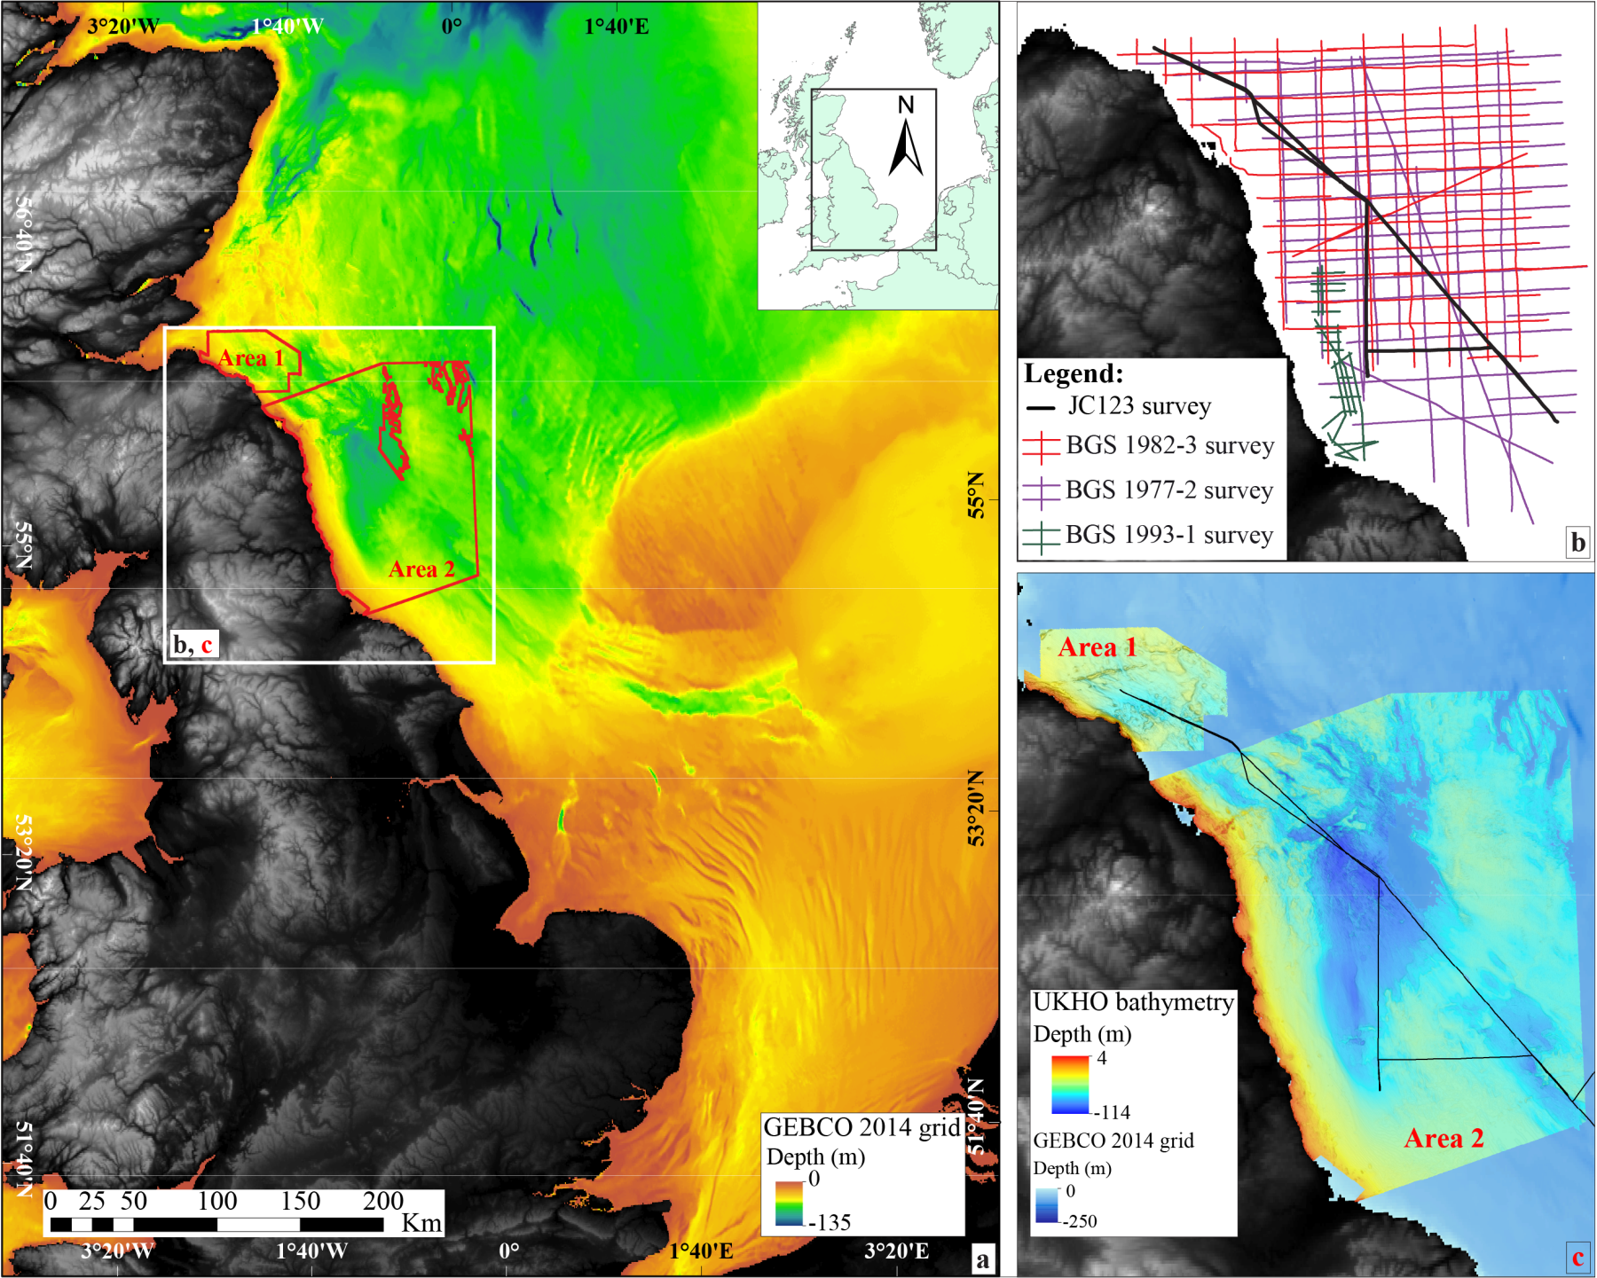
Figure 1: a) Overview of the western North Sea bathymetry (GEBCO, 2014 grid) and location of the research area (white square). An orange-green colour scale was used to better highlight the geomorphology of the seafloor. b): Location of the JC123 survey track (black line) and of the BGS surveys. c): Location of Area 1 and 2 of the UKHO bathymetry dataset.

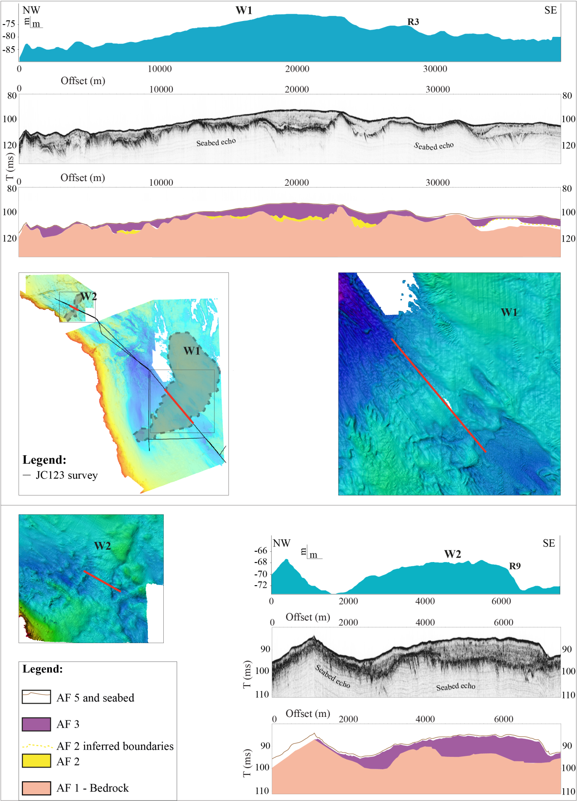
Figure 2: Bathymetric and seismic profiles and facies interpretation of the grounding zone wedges W1 and W2. The wedges and the profiles location (red line) are shown in the insert map. UKHO bathymetry close-ups are also shown (locations indicated with black squares in the map). Note that the seismic profiles are vertically exaggerated.

